Project Design Phase-II
Data Flow Diagram & User Stories

Date | 27 June 2026
Team ID
Project Name | SB Stocks – Paper Trading Platform
Maximum Marks | 4 Marks

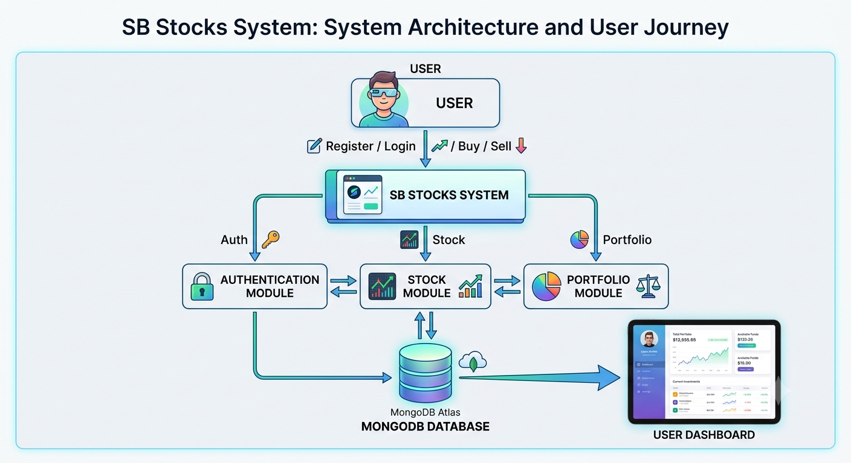
Data Flow Diagram (Level-0)

User Stories
User Type | Functional Requirement (Epic) | User Story No. | User Story / Task | Acceptance Criteria | Priority | Release
Customer (Web User) | Registration | USN-1 | As a user, I can register by entering my name, email, and password. | User account is created successfully. | High | Sprint-1
Customer (Web User) | Login | USN-2 | As a user, I can log in using my registered email and password. | User is redirected to the dashboard after successful login. | High | Sprint-1
Customer (Web User) | Dashboard | USN-3 | As a user, I can view my virtual balance, portfolio count, and transaction count. | Dashboard displays user information correctly. | High | Sprint-1
Customer (Web User) | View Stocks | USN-4 | As a user, I can view all available stocks with company details. | Stock list is displayed successfully. | High | Sprint-1
Customer (Web User) | Search Stocks | USN-5 | As a user, I can search stocks using company name or symbol. | Matching stocks are displayed instantly. | Medium | Sprint-1
Customer (Web User) | Buy Stocks | USN-6 | As a user, I can purchase stocks using my virtual balance. | Stock is added to the portfolio and balance is updated. | High | Sprint-2
Customer (Web User) | Portfolio | USN-7 | As a user, I can view all purchased stocks. | Portfolio displays purchased stocks correctly. | High | Sprint-2
Customer (Web User) | Sell Stocks | USN-8 | As a user, I can sell stocks from my portfolio. | Portfolio and balance are updated after selling. | High | Sprint-2
Customer (Web User) | Transactions | USN-9 | As a user, I can view my complete transaction history. | All buy and sell transactions are displayed. | High | Sprint-2
Customer (Web User) | Logout | USN-10 | As a user, I can securely log out of the application. | User session ends and redirects to the login page. | High | Sprint-2
Administrator | User Management | USN-11 | As an administrator, I can manage registered users. (Future Enhancement) | Administrator can monitor user records. | Low | Sprint-3
Administrator | Stock Management | USN-12 | As an administrator, I can add, update, or remove stocks. (Future Enhancement) | Stock database is updated successfully. | Medium | Sprint-3

Sprint Planning

Sprint 1
- User Registration
- User Login
- JWT Authentication
- Dashboard
- View Stocks
- Search Stocks

Sprint 2
- Buy Stocks
- Sell Stocks
- Portfolio Management
- Transaction History
- Logout

Sprint 3 (Future Enhancements)
- Admin Panel
- Stock Management
- User Management
- Live Stock API Integration

Actors

Primary Actor
- Customer (Web User)

Secondary Actor
- Administrator (Future Enhancement)

